SED Stream editor – Kali
Substitute Text (s/find/replace/)
Replace sed with command in a sentence.
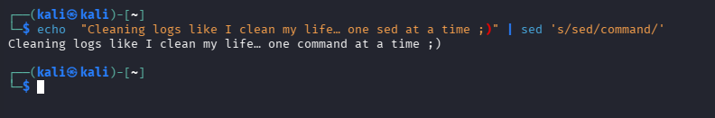
Create a file
nano fun.log > CTRL+O, CTRL+X, ENTER
INFO: Started my DevOps journey with full motivation
WARNING: Motivation dropped after first error
ERROR: Googled the same error 25 times
INFO: Fixed issue accidentally without understanding
WARNING: Afraid to touch anything now
ERROR: Broke working system while trying to improve it
INFO: Said "it’s working" and moved on quickly
WARNING: Terminal staring back like it knows everything
ERROR: Copy-pasted command from internet and prayed
INFO: Slowly becoming confident… but still scared

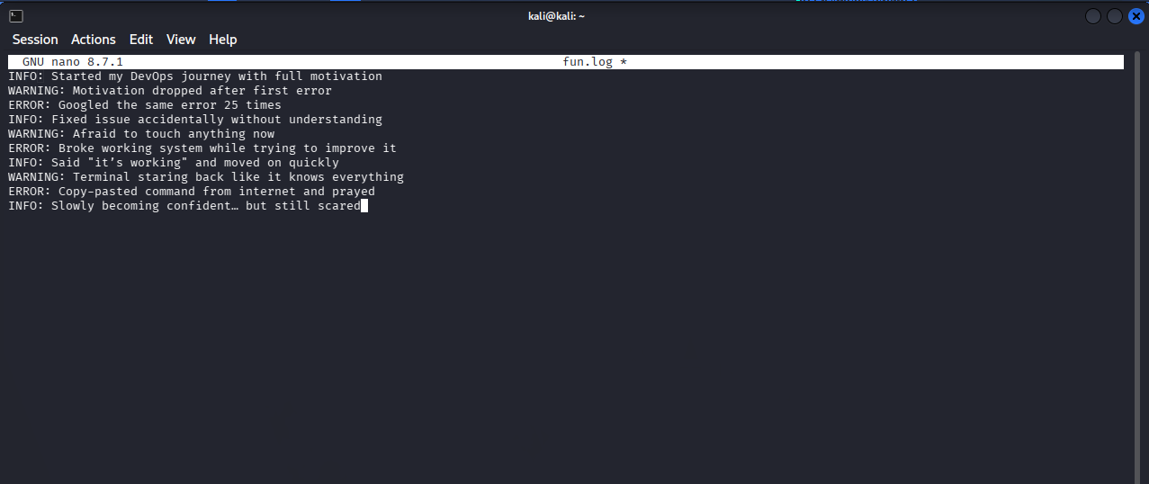

With Grep: grep -I error fun.log
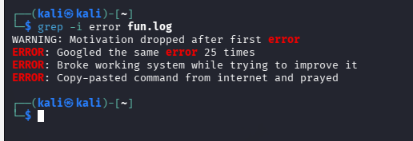
With awk: awk ‘{print $1}’ fun.log
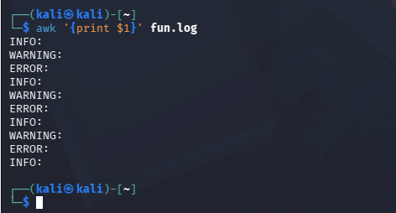

With sed: sed ‘s/ERROR:/FIXED:/g’ fun.log
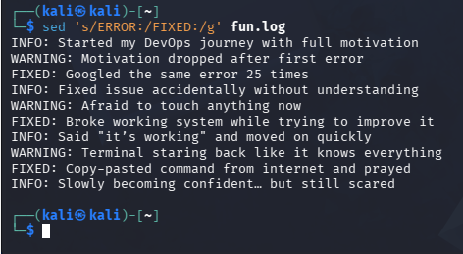

Delete the 1-2 lines: sed ‘1,2d’ fun.log
